

Static Web Page Design

LAB MANUAL

Department

Of

Computer Engineering

# Neotech Faculty of Diploma Engineering

**Name: - _________________________________________________________________________________________**

**Branch: - _________________________________ Division: - _________________________________________**

**Roll No: - ___________________________________ Year: - ___________________________________________**

**NEOTECH FACULTY OF DIPLOMA ENGINEERING**

**Static Web Page Design(4311603)**



Neotech Faculty Of

Diploma Engineering

Virod, Vadodara.

CERTIFICATE

This is to certify that

Mr./Ms. Enrollment No. of 2nd Semester Diploma course in

has satisfactorily completed his/her termwork in

within four walls of institute during the year 2022.

Place:

Date:

Subject Teacher Head of Department

**Subject: Static Web Page Design**

## Subject Code : 4311603

**LIST OF EXPERIMENTS**

|  |  |  |  |  |
| --- | --- | --- | --- | --- |
| **Sr.**  **NO.** | **TITLE OF EXPERIMENT** |  | **Date** | **Sign** |
| 1. | Use HTML text formatting tags to create web page as per given sample. |  |  |  |
| 2. | Use hyper link tag to navigate through different web pages as per given sample. |  |  |  |
| 3. | Use image tags to create web page as per given sample. |  |  |  |
| 4. | Use HTML table tags to create web page as per given sample. |  |  |  |
| 5. | Use sorted list to create web page as per given sample page |  |  |  |
| 6. | Use unsorted list to create web page as per given sample page. |  |  |  |
| 7. | Use definition list to create web page as per given sample page. |  |  |  |
| 8. | Use semantic tags to organize web page contents as per given sample. |  |  |  |
| 9. | a. Create a student registration webpage using different HTML form elements.  b. Create student feedback form using different HTML form elements. |  |  |  |
| 10. | Create a bank account opening form using different HTML form elements in Kompozer |  |  |  |
| 11. | Use inline, internal and external style sheets for the student registration form and bank account form created in previous practical. |  |  |  |
| 12. | a. Use different CSS elements to create and format your Profile Page (Note: use CSS Background, Text, Font, Tables, Links, Images, Margin etc)  b. Create and format your class time table Page Using Different CSS Elements (Note: use CSS Background, Text, Font, Tables, Links, Images, Margin etc) |  |  |  |
| 13. | Use JavaScript to perform the following operations: a. find roots of quadratic equation b. find the highest from given three values |  |  |  |
| 14. | Use JavaScript to check whether given character is vowel or consonant using if else ladder. |  |  |  |
| 15. | Use JavaScript to check whether given character is vowel or consonant using switch case. |  |  |  |
| 16. | Use JavaScript to print first 10 even numbers. |  |  |  |
| 17. | Use JavaScript to calculate power of given number. |  |  |  |
| 18. | Use JavaScript to print multiplication table of given number. |  |  |  |
| 19. | Use JavaScript user defined functions to perform the following operations:  a. to calculate sum of 1 to n  b. to check whether given number is prime or not |  |  |  |
| 20. | Use JavaScript to perform the following operations:  a. take input of student name and address and display in a dialog box.  b. change background color of webpage as selected by user from a list of colors given in combo box. |  |  |  |
| 21. | Use JavaScript to perform the following operations:  a. calculate the factorial of a given number entered into a textbox. Display the result in another textbox.  b. perform arithmetic operations on two numbers entered into textboxes. Use Radio buttons to select arithmetic operations (Addition, Subtraction, Multiplication and Division). Display the result in another textbox. |  |  |  |

### Experiment No:- 1 Date: / /

**Aim :** **Use HTML text formatting tags to create web page as per given sample.**

**1.Paragraph in HTML page:**

<HTML>

<HEAD>

<TITLE>Title of this page</TITLE>

</HEAD>

<BODY>

<p> Another line behind this statement.</p>

<p>Paragraph is over here. </p>

<p>Here is new line. </p>

<NOBR>

<p>This line don’t write on another line. </p>

<p>This line don’t write on another line. </p>

<p>This line don’t write on another line. </p>

</NOBR>

<P>

End line.

</p>

<HR>

</BODY>

</HTML>

**Output:**

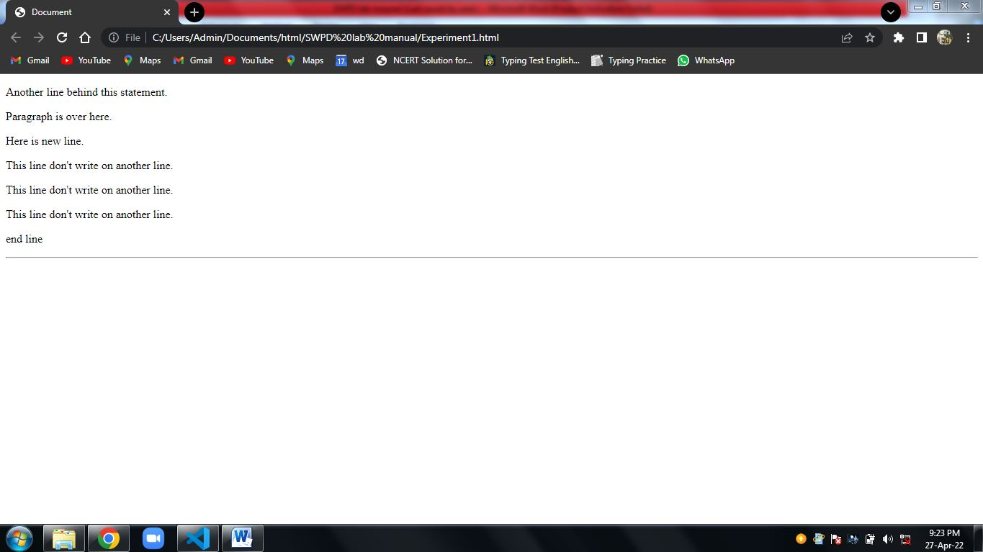

### 2.) Html color

**Aim :** **Use HTML text formatting tags to create web page as per given sample.**

Backgroung color using HTML

<HTML>

<HEAD>

<TITLE>Title of this page</TITLE>

</HEAD>

<BODY BGCOLOR=”Aqua”>

<H1><FONT COLOR=”#FF00FF”>Welcome</FONT></H1>

</BODY>

</HTML>

**Output:**

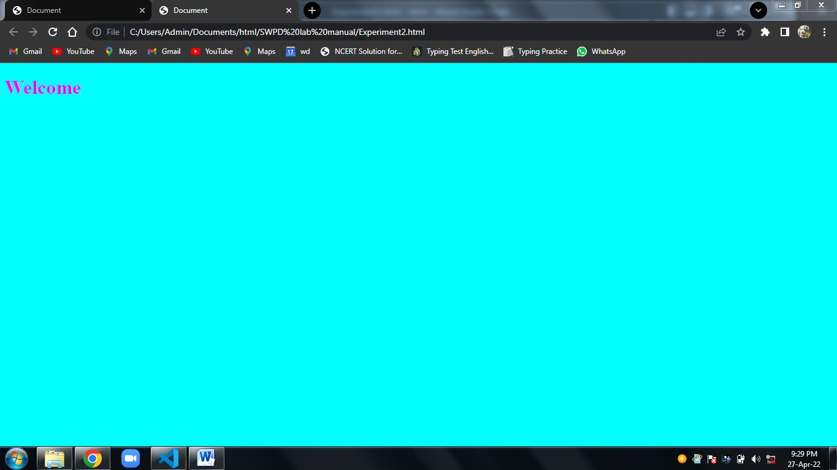

### Experiment No:- 2 Date: / /

**3. Hyperlink** **in HTML**

**HTMl file 1**

<HTML>

<HEAD>

<TITLE>Title of this page</TITLE>

</HEAD>

<BODY>

<H1><a href =”link.html”>click this link<a/> </H1>

</BODY>

</HTML>

**HTMl file 2**

<HTML>

<HEAD>

<TITLE>Title of this page</TITLE>

</HEAD>

<BODY>

<H1>This page open with the hyper link </H1>

</BODY>

</HTML>

Output:

Page 1

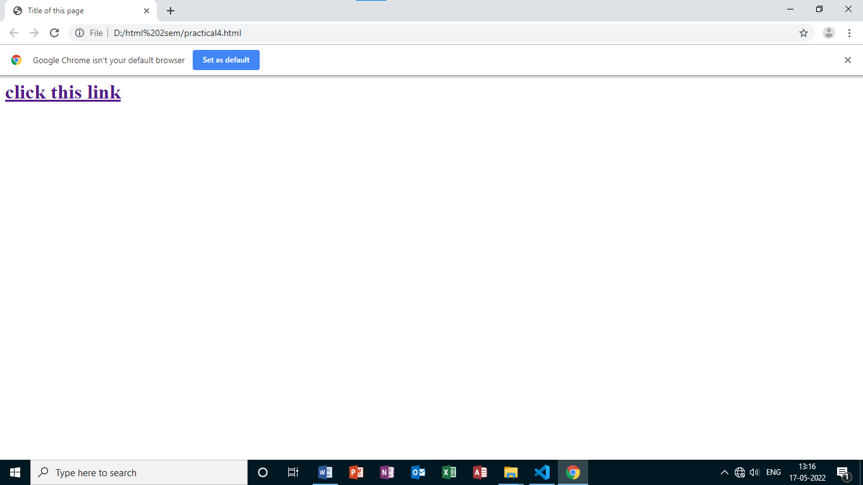

Page 2

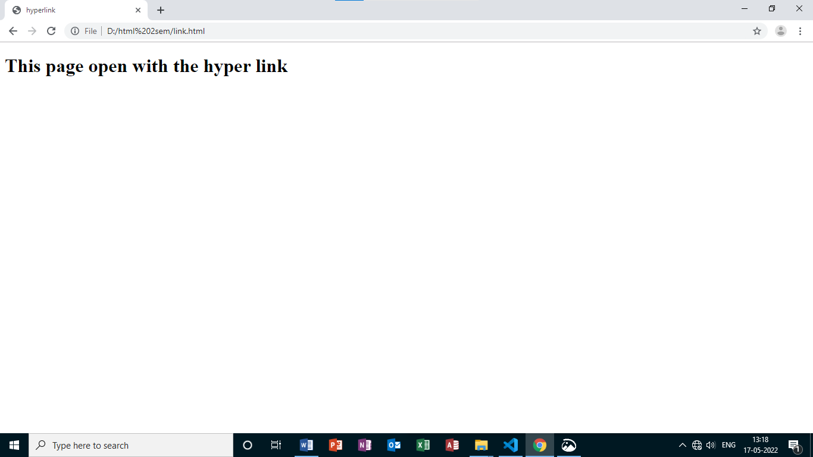

### Experiment No:- 4 Date: / /